December Newsletter
Keswick Ridge School
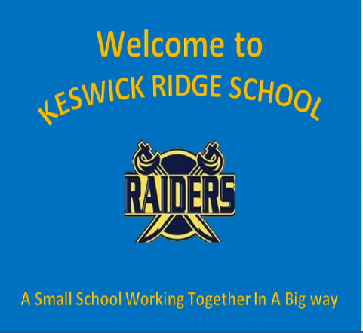

Upcoming Events

December 6th – 10th
Theme Days:
Mon – Winter Character
Tue – Buffalo Plaid
Wed – Festive Hats
Thursday – Festive Sweaters
Friday – PJ Day
December 15th
Christmas Concert Recording
December 17th
Christmas Concert Broadcast
December 23rd
Last Day for Students

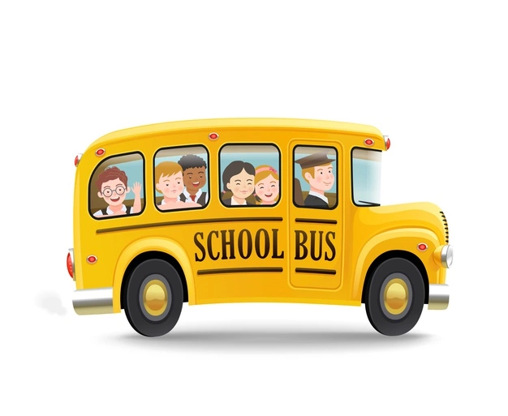
For all bussing inquiries, please call (506) 453-5454 or go to:
https://asdwbp.nbed.nb.ca/

166 McKeen Drive, Keswick Ridge, E6L 1N9
(506) 363-4703
Acting Principal: Chris Roach
Acting Vice-Principal: Melissa Chetwynd
Hello KRS Families,
Christmas Concert
Each class has chosen a song to record for our virtual concert. The concert will be broadcast via Microsoft Teams on Friday, December 17th at 10:00 a.m. and 6:00 p.m. A recording will also be available for those who aren’t able to tune in at those times.
Covid Update
We are currently well into cold and flu season. If you or anyone in your household is exhibiting Covid symptoms, or have been designated as a close contact to someone with Covid, please call 811 or contact Public Health and follow their recommended guidelines.
Weather and Proper Dress
Winter weather has arrived. Please ensure that students are arriving to school dressed appropriately. The temperature cut-off for outdoor recess is -20 C. School closure information can be found at:
http://web1.nbed.nb.ca/sites/asd-w/Pages/default.aspx
Communication
Don’t forget that we communicate regularly through both our Keswick Ridge School Facebook page as well as our website:
https://secure1.nbed.nb.ca/sites/ASD-W/KeswickRidge/Pages/default.aspx

Visitors
As a precaution, we are not allowing visitors to enter the building without an appointment. To make an appointment please contact your child’s teacher or the main office at (506) 363-4703

Communication
Don’t forget that we communicate regularly through both our Keswick Ridge School Facebook page as well as our website:
https://secure1.nbed.nb.ca/sites/ASD-W/KeswickRidge/Pages/default.aspx

